This Bookstore Management System is my intermediate computer science project. This system is designed and developed to handle various functions. Here is an interesting feature of getting a live summary from Wikipedia for books in a library. This opened to me the techniques of online API handling. The code follows the app screen shots below.
App Screen shots:
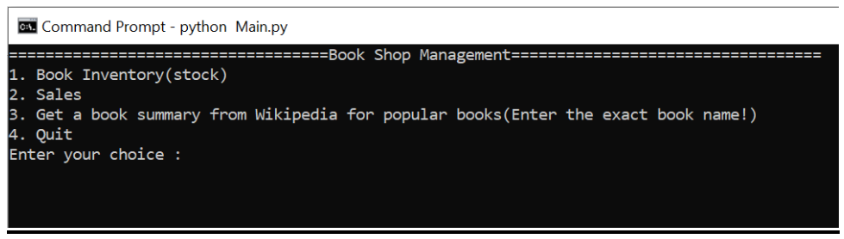

GET A BOOK SUMMARY FROM WIKIPEDIA FOR POPULAR BOOKS
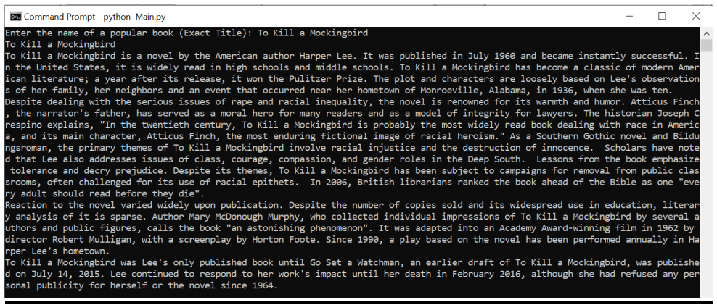
Corresponding code. Looks simple here, but I learned a lot when finalizing it:
import wikipedia as wp
wikiquery = (input("Enter the name of a popular book (Exact Title): "))
try:
print(wikiquery)
print(wp.summary(wikiquery, auto_suggest=False))
print (" ")
print (" ")
except:
print (" ")
print ("-----------------------------------------------------------")
print ("There is no book-page for"+wikiquery+" in wikipedia")
print ("-----------------------------------------------------------")

